- Go to git hub https://github.com/ and enter your email.


- Enter strong password and verify your self as a valid user.
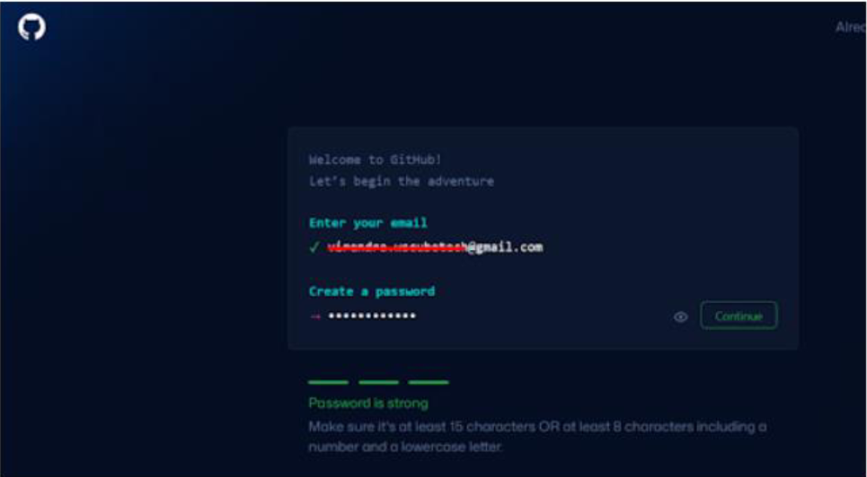

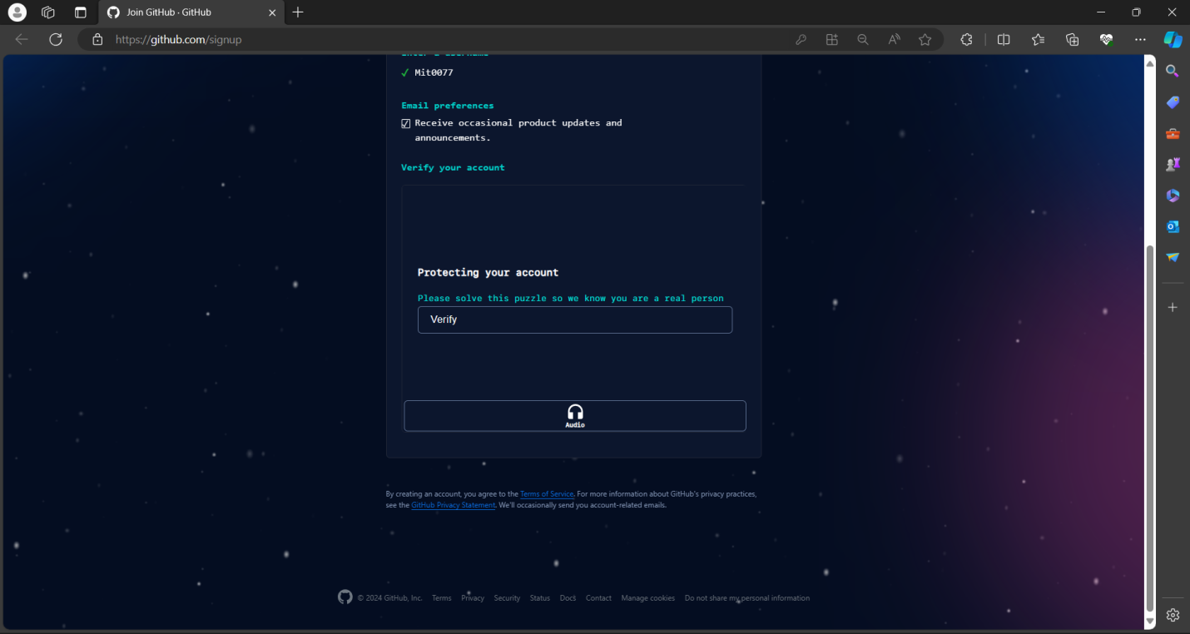

- Then login to your account.
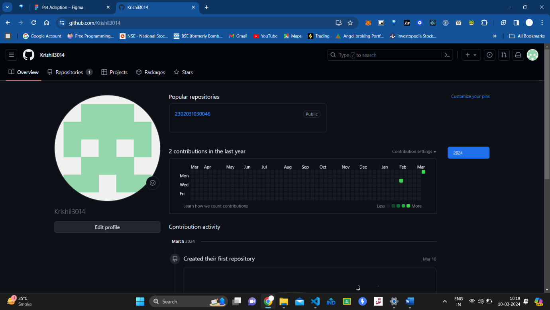

- Click on new option and enter your repo name”2302031030072”. And select public profile and check create README file. And then click on create repository.
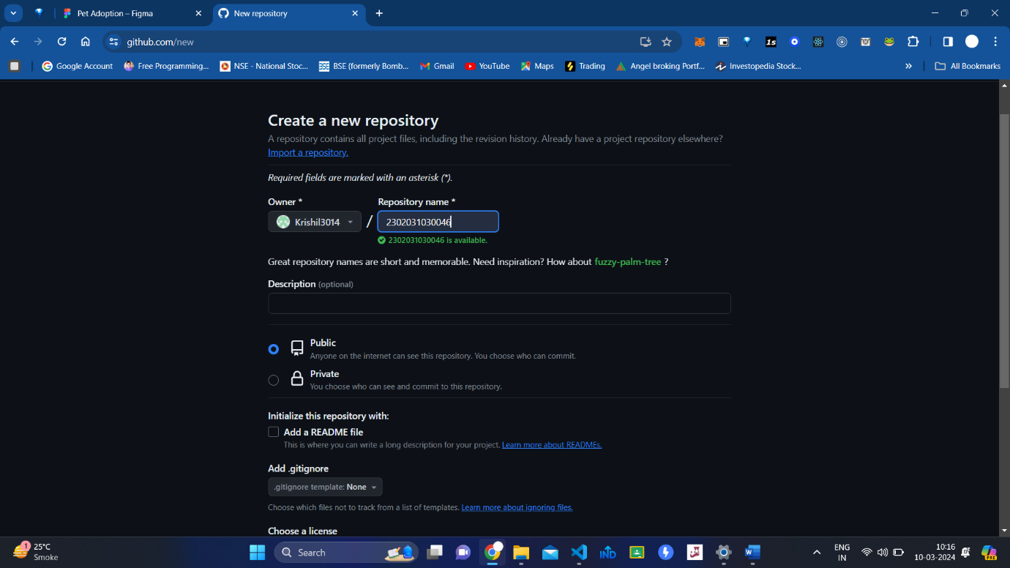

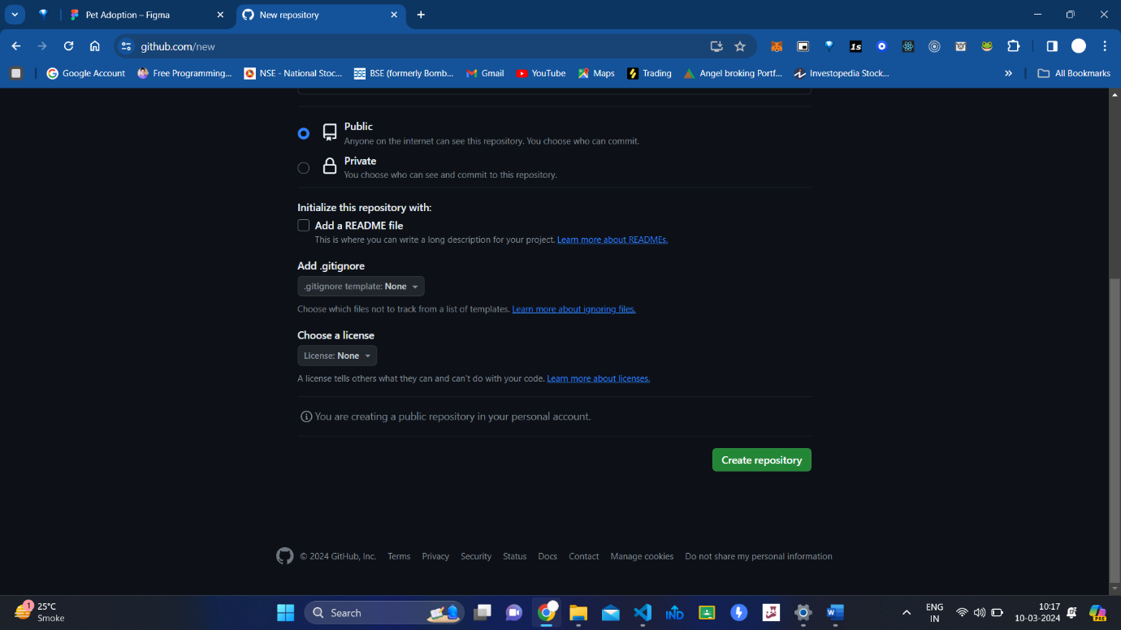
- And you are successfully done

- Then go to your repository and click on add file>create new file.

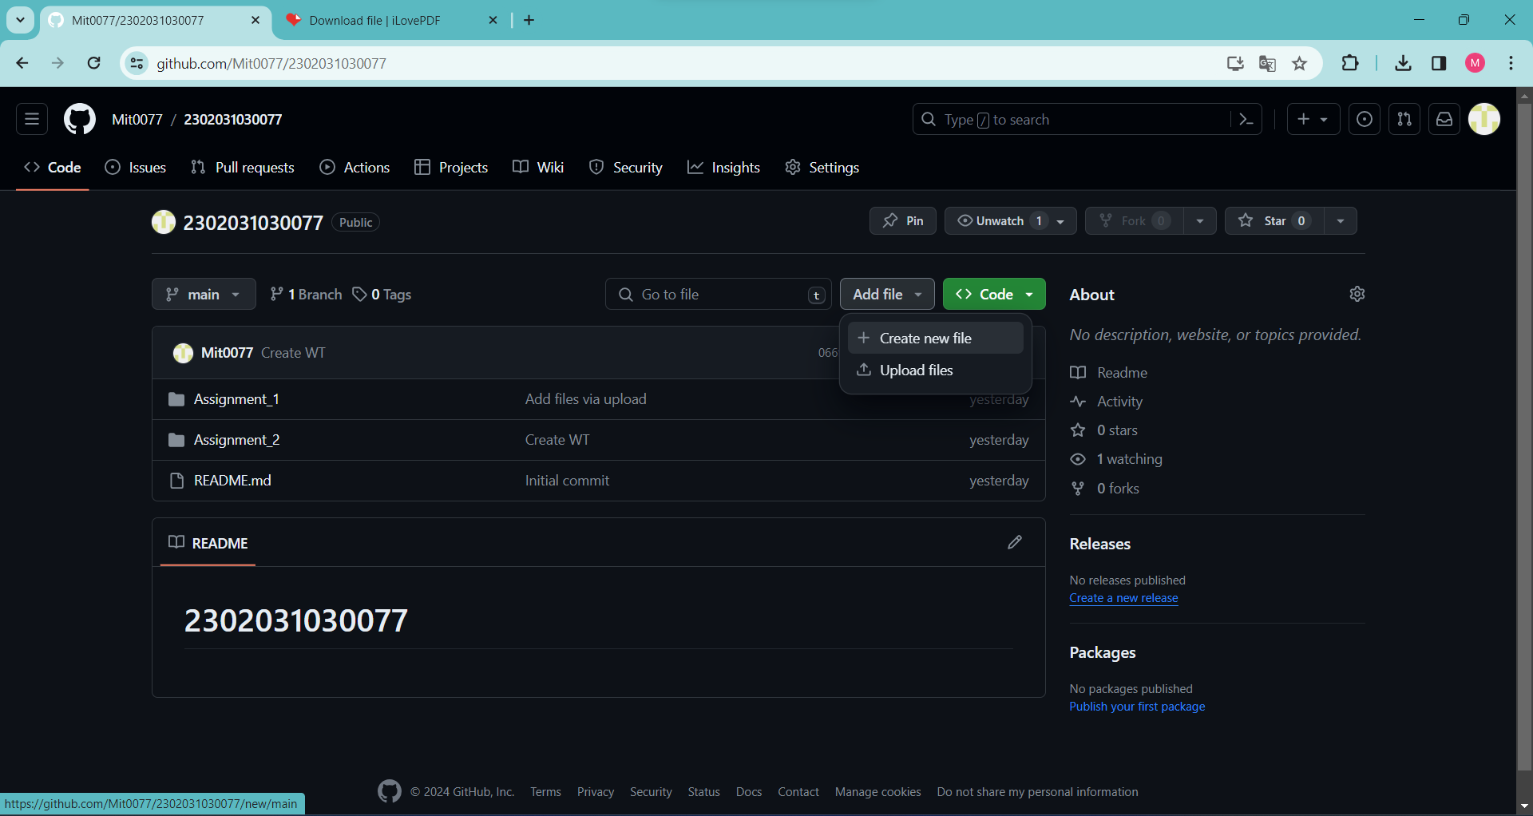
7.Enter the name of your folder”Assignment_1”.and add ”/” to make folder then click on commit changes. 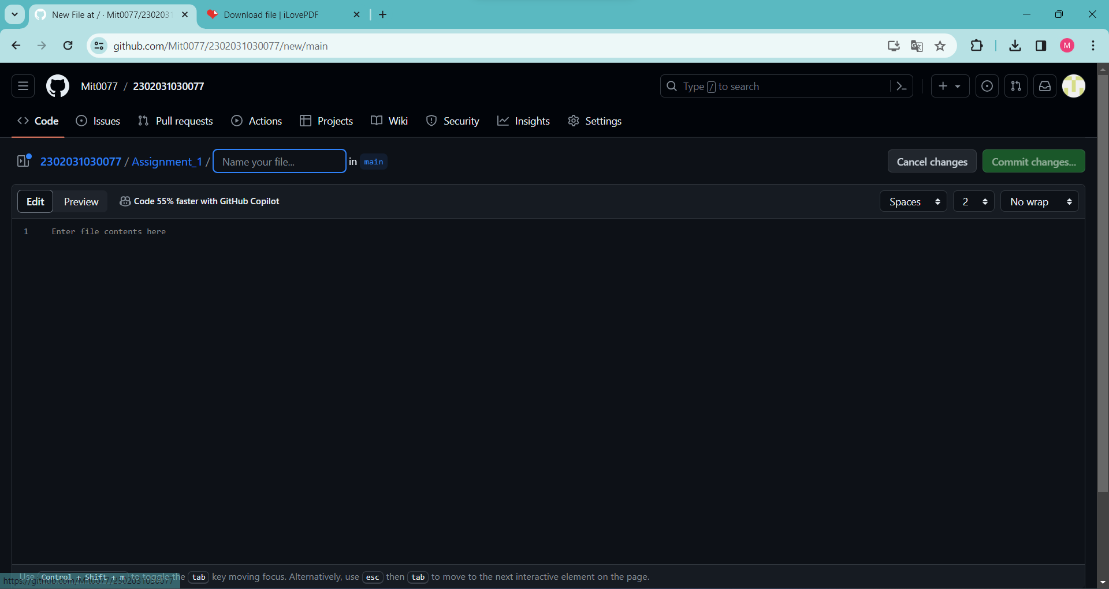
- You done in making a folder in git hub and it is ready to upload files.

